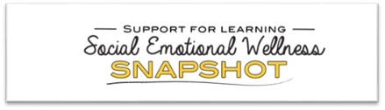

[November 2020 Secondary Snapshot -Social Emotional Learning: Strategies for Parents](https://healthyschools.sd61.bc.ca/newsletters/secondary-2020/)

